Name: Twana Nareman Qader G A-2 IT-level 1

=********************************************************************=

Homework AND get to four input

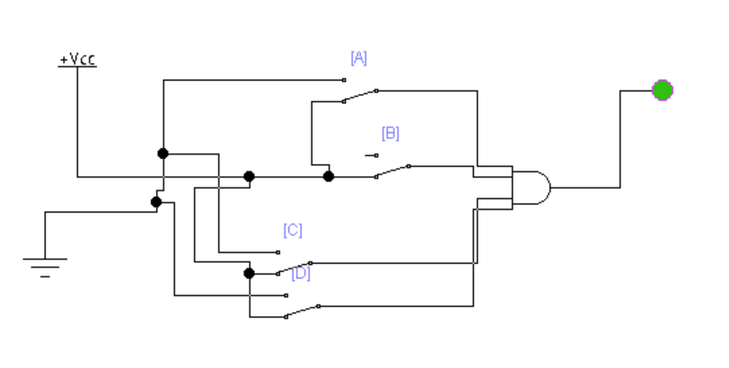

|  |  |  |  |  |  |
| --- | --- | --- | --- | --- | --- |
|  | Input | | | |  |
| line | A | B | C | D | output |
| 0 | 0 | 0 | 0 | 0 | **0** |
| 1 | 0 | 0 | 0 | 1 | **0** |
| 2 | 0 | 0 | 1 | 0 | **0** |
| 3 | 0 | 0 | 1 | 1 | **0** |
| 4 | 0 | 1 | 0 | 0 | **0** |
| 5 | 0 | 1 | 0 | 1 | **0** |
| 6 | 0 | 1 | 1 | 0 | **0** |
| 7 | 0 | 1 | 1 | 1 | **0** |
| 8 | 1 | 0 | 0 | 0 | **0** |
| 9 | 1 | 0 | 0 | 1 | **0** |
| 10 | 1 | 0 | 1 | 0 | **0** |
| 11 | 1 | 0 | 1 | 1 | **0** |
| 12 | 1 | 1 | 0 | 0 | **0** |
| 13 | 1 | 1 | 0 | 1 | **0** |
| 14 | 1 | 1 | 1 | 0 | **0** |
| 15 | 1 | 1 | 1 | 1 | **1** |

Homework OR for five input

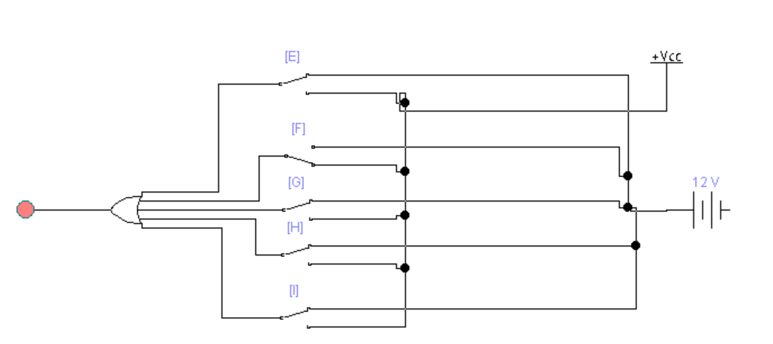

|  |  |  |  |  |  |  |
| --- | --- | --- | --- | --- | --- | --- |
|  | Input | | | | |  |
| Line | **E** | **F** | **G** | **H** | **I** | **output** |
| 0 | **0** | 0 | 0 | 0 | 0 | 0 |
| 1 | **0** | 0 | 0 | 0 | 1 | 1 |
| 2 | **0** | 0 | 0 | 1 | 0 | 1 |
| 3 | **0** | 0 | 0 | 1 | 1 | 1 |
| 4 | **0** | 0 | 1 | 0 | 0 | 1 |
| 5 | **0** | 0 | 1 | 0 | 1 | 1 |
| 6 | **0** | 0 | 1 | 1 | 0 | 1 |
| 7 | **0** | 0 | 1 | 1 | 1 | 1 |
| 8 | **0** | 1 | 0 | 0 | 0 | 1 |
| 9 | **0** | 1 | 0 | 0 | 1 | 1 |
| 10 | **0** | 1 | 0 | 1 | 0 | 1 |
| 11 | **0** | 1 | 0 | 1 | 1 | 1 |
| 12 | **0** | 1 | 1 | 0 | 0 | 1 |
| 13 | **0** | 1 | 1 | 0 | 1 | 1 |
| 14 | **0** | 1 | 1 | 1 | 0 | 1 |
| 15 | **0** | 1 | 1 | 1 | 1 | 1 |
| 16 | 1 | 0 | 0 | 0 | 0 | 1 |
| 17 | 1 | 0 | 0 | 0 | 1 | 1 |
| 18 | 1 | 0 | 0 | 1 | 0 | 1 |
| 19 | 1 | 0 | 0 | 1 | 1 | 1 |
| 20 | 1 | 0 | 1 | 0 | 0 | 1 |
| 21 | 1 | 0 | 1 | 0 | 1 | 1 |
| 22 | 1 | 0 | 1 | 1 | 0 | 1 |
| 23 | 1 | 0 | 1 | 1 | 1 | 1 |
| 24 | 1 | 1 | 0 | 0 | 0 | 1 |
| 25 | 1 | 1 | 0 | 0 | 1 | 1 |
| 26 | 1 | 1 | 0 | 1 | 0 | 1 |
| 27 | 1 | 1 | 0 | 1 | 1 | 1 |
| 28 | 1 | 1 | 1 | 0 | 0 | 1 |
| 29 | 1 | 1 | 1 | 0 | 1 | 1 |
| 30 | 1 | 1 | 1 | 1 | 0 | 1 |
| 31 | 1 | 1 | 1 | 1 | 1 | 1 |